**PROJECT REPORT**



**Spring 2022**

**CSE102L Computer Programming Lab**

Suleman Shah (**21PWCSE1983)**

Shahzad Bangash (**21PWCSE1980)**

Ali Asghar (**21PWCSE2059)**

“On my honor, as student of University of Engineering and Technology, I have neither given nor received unauthorized assistance on this academic work.”

Submitted to:

**Engr. Abdullah Hamid**

July 27, 2022

Department of Computer Systems Engineering

University of Engineering and Technology, Peshawar

**SOCCER PINBALL GAME**

**SOCCER PINBALL:**

Soccer Pinball Game blends the challenges of soccer and pinball in one game. It is a hyper-casual game with fun and challenging mixed gameplay of soccer and pinball. This game truly fulfills the desire of both soccer and pinball game fans.

**HYPER-CASUAL GAME:**

A **hyper-casual game** is a lightweight game with minimal design. They are relatively easy to produce, but they guarantee to offer a high level of entertainment and enjoyment.

**FRAMEWORK USED:**

Unity and C#.

**TOPICS USED FROM COURSE IN PROJECT:**

* Objects and Classes(Object Oriented Programming)
* Basic Data types(bool, float, integer)
* Functions
* Selection Statements(if-else statements)
* Function Parameters
* Logical Operators

**HOW TO PLAY:**

When you hit the play button, the ball is randomly spawned in ground, then it falls down to your goal. Using the left and right flippers, save the goal by not letting the ball fall into your goal. Up ahead, there’s an enemy goal. By scoring goal on enemy, you will earn score. Each time you score highest score, it is saved.

**CONTROLS:**

Right and left flippers can be controlled by D and A keys respectively

**APPLICATIONS:**

Hyper casual games market is rapidly growing day by day and the day will come when hyper casual games would rule the game market. As our project is a hyper casual game, it is mostly used for entertainment purposes. It can be a great time killer and stress releaser for gamers. Apart from this, publishers are also interested in publishing hyper casual games. Hyper casual games are easy to create and play as compared to complex RPG games.

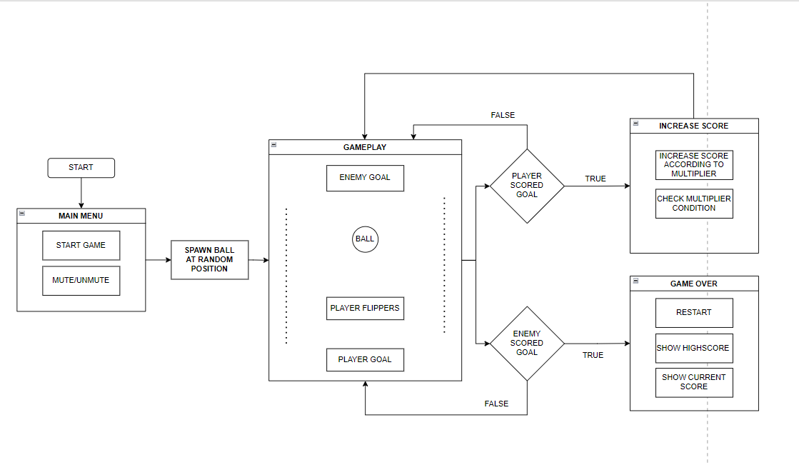

**GAME FLOWCHART**

**CODE SCREENSHOTS:**

**Ball Controller**

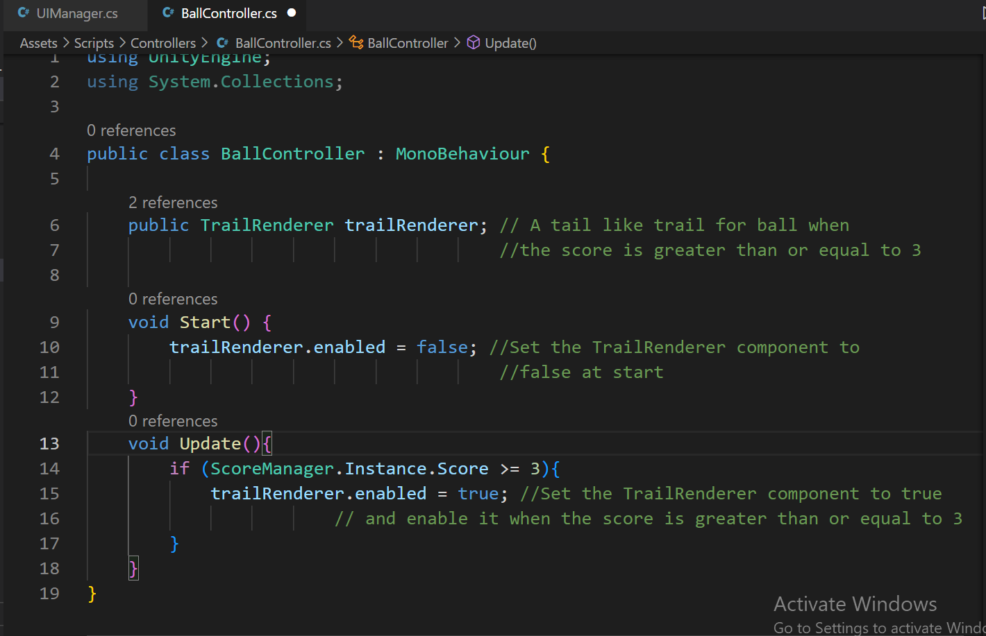

**Enemy Goal Controller**

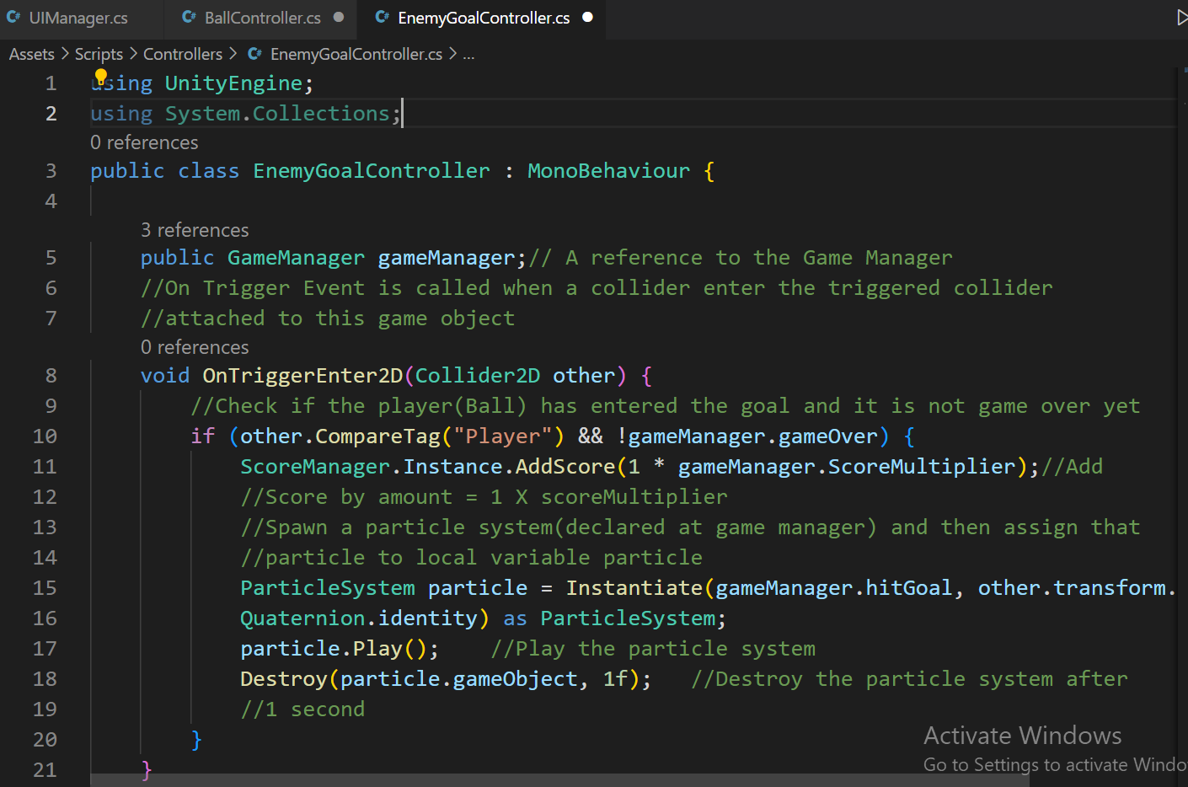

**Player Goal Controller**

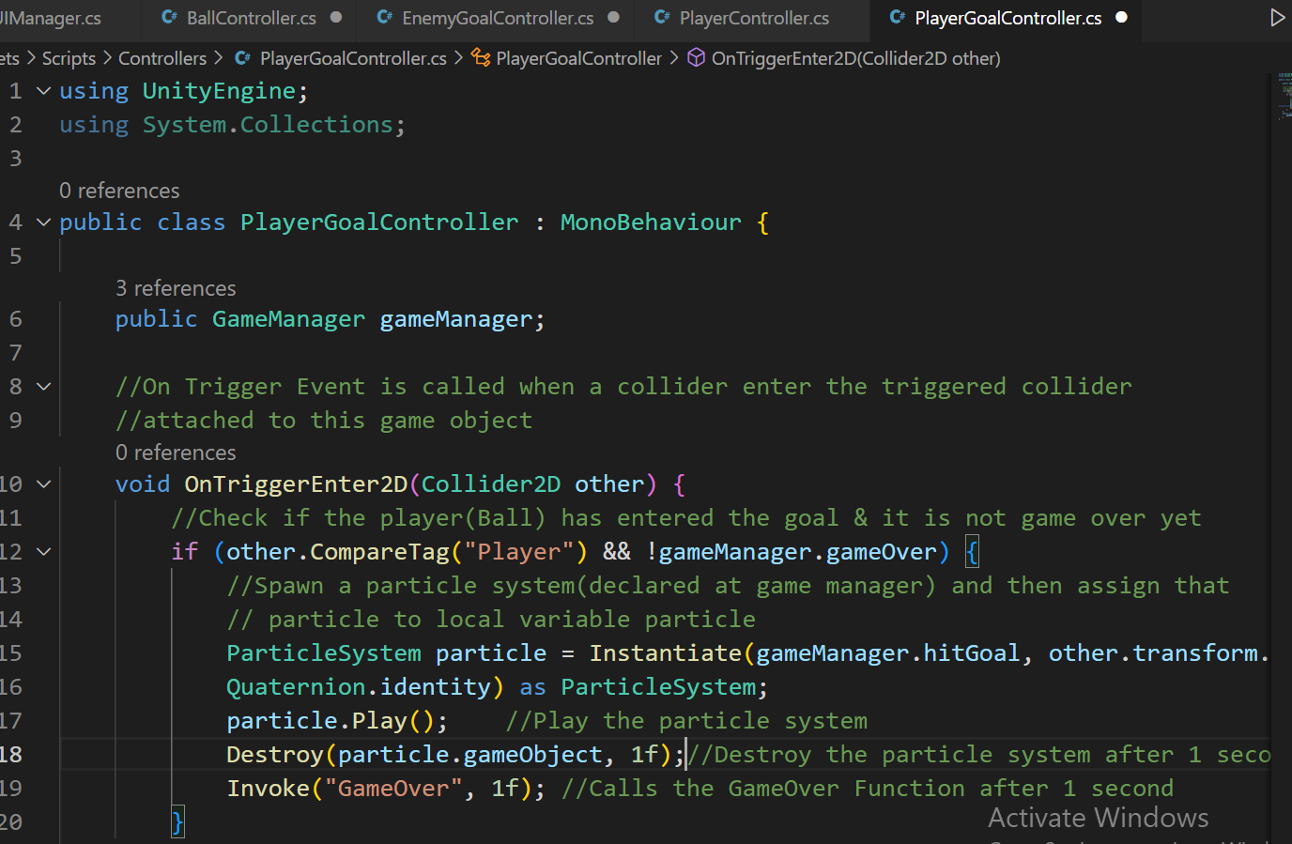

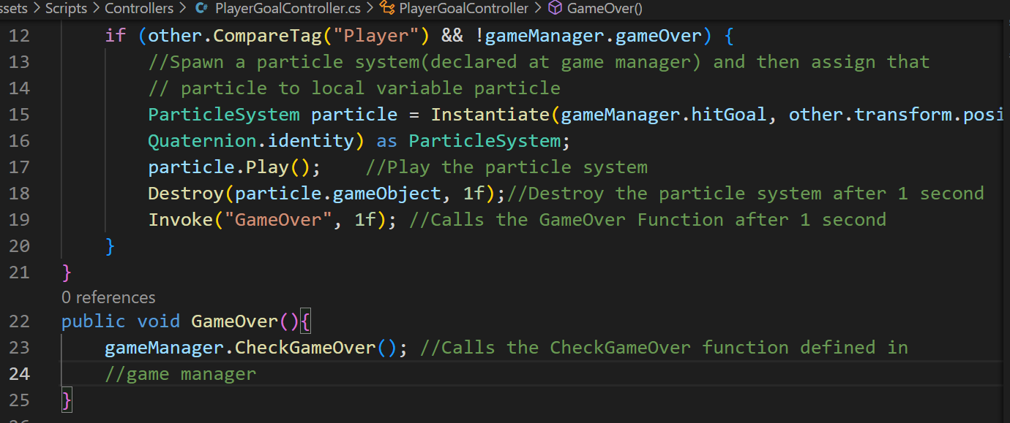

**Player Controller**

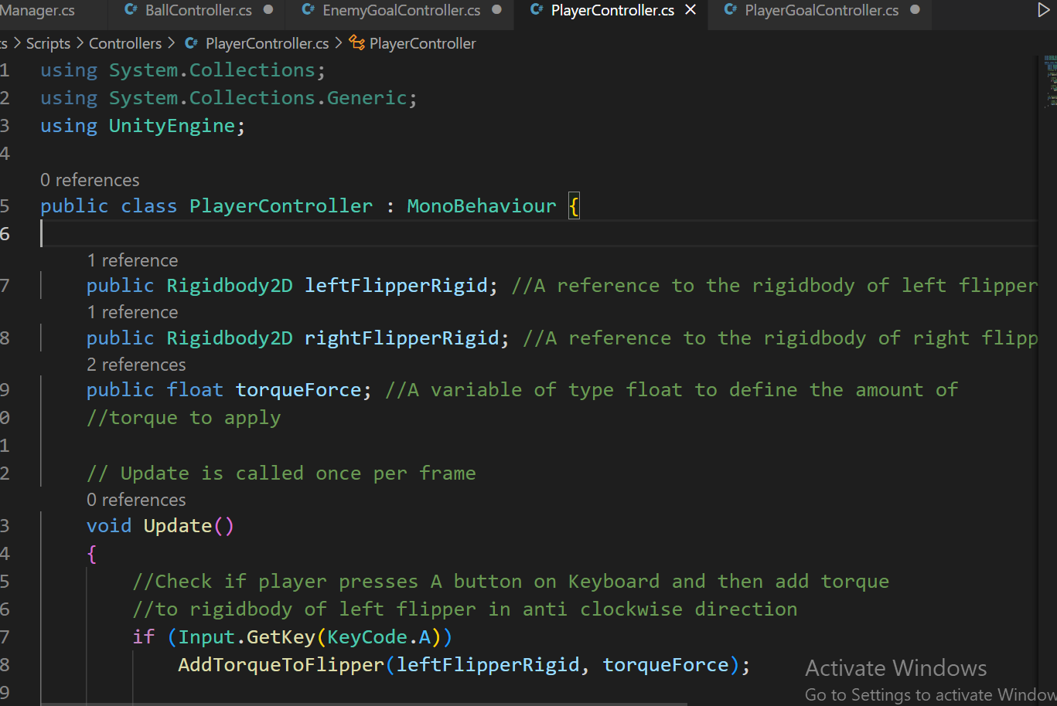

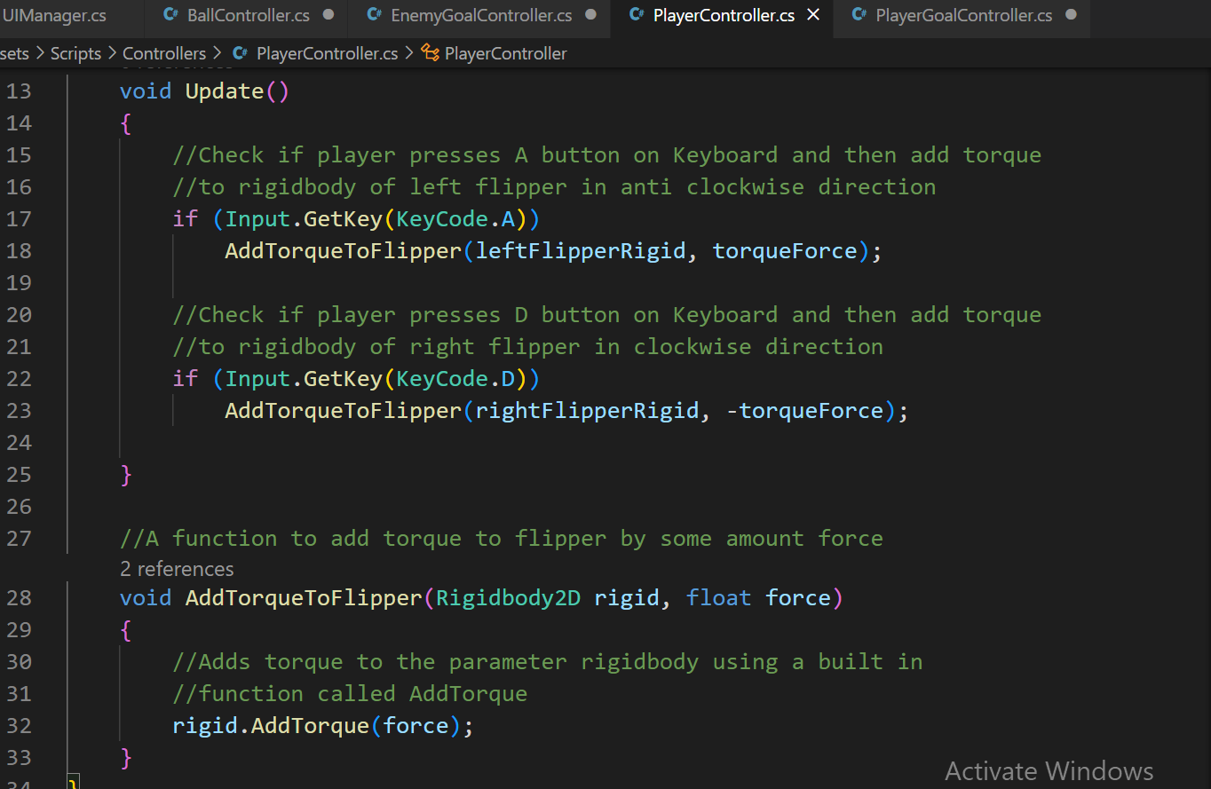

**Game Manager**

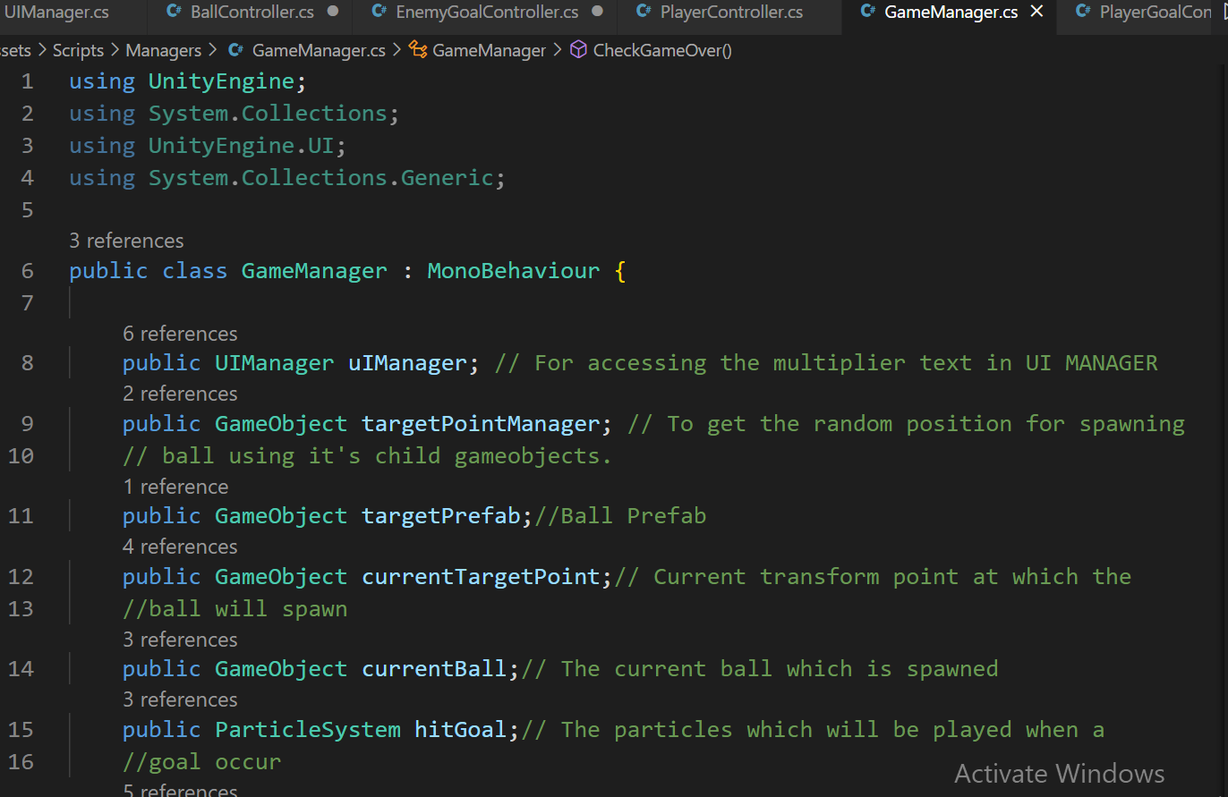

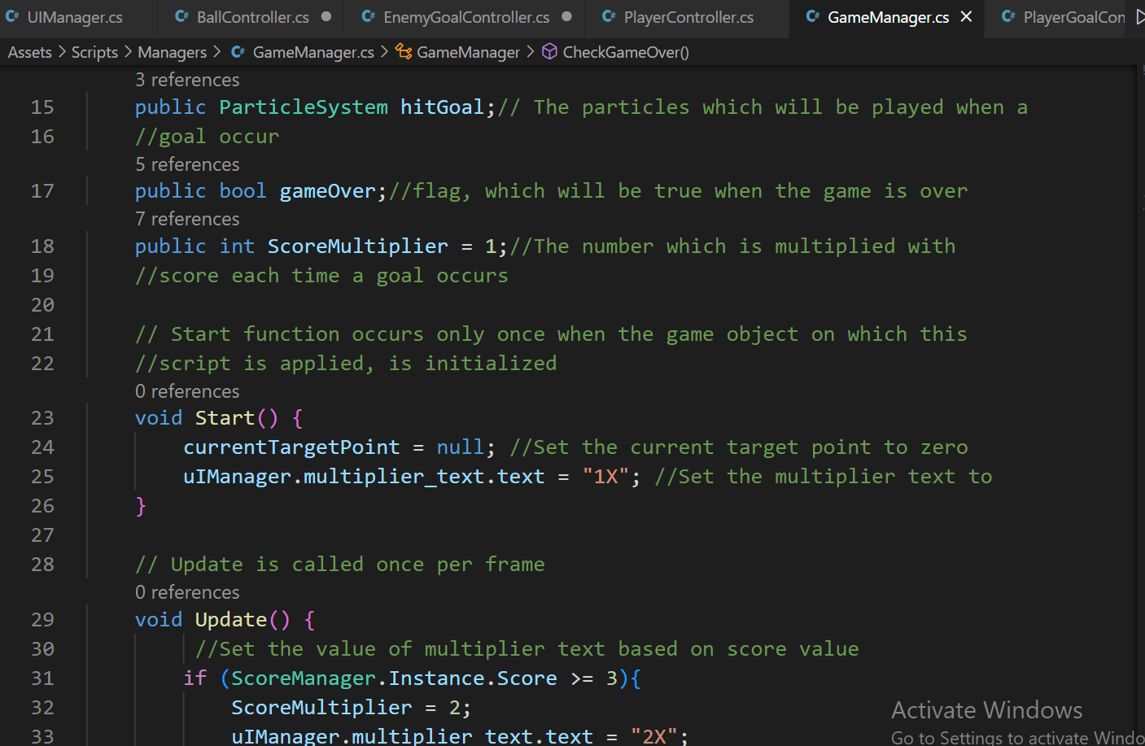

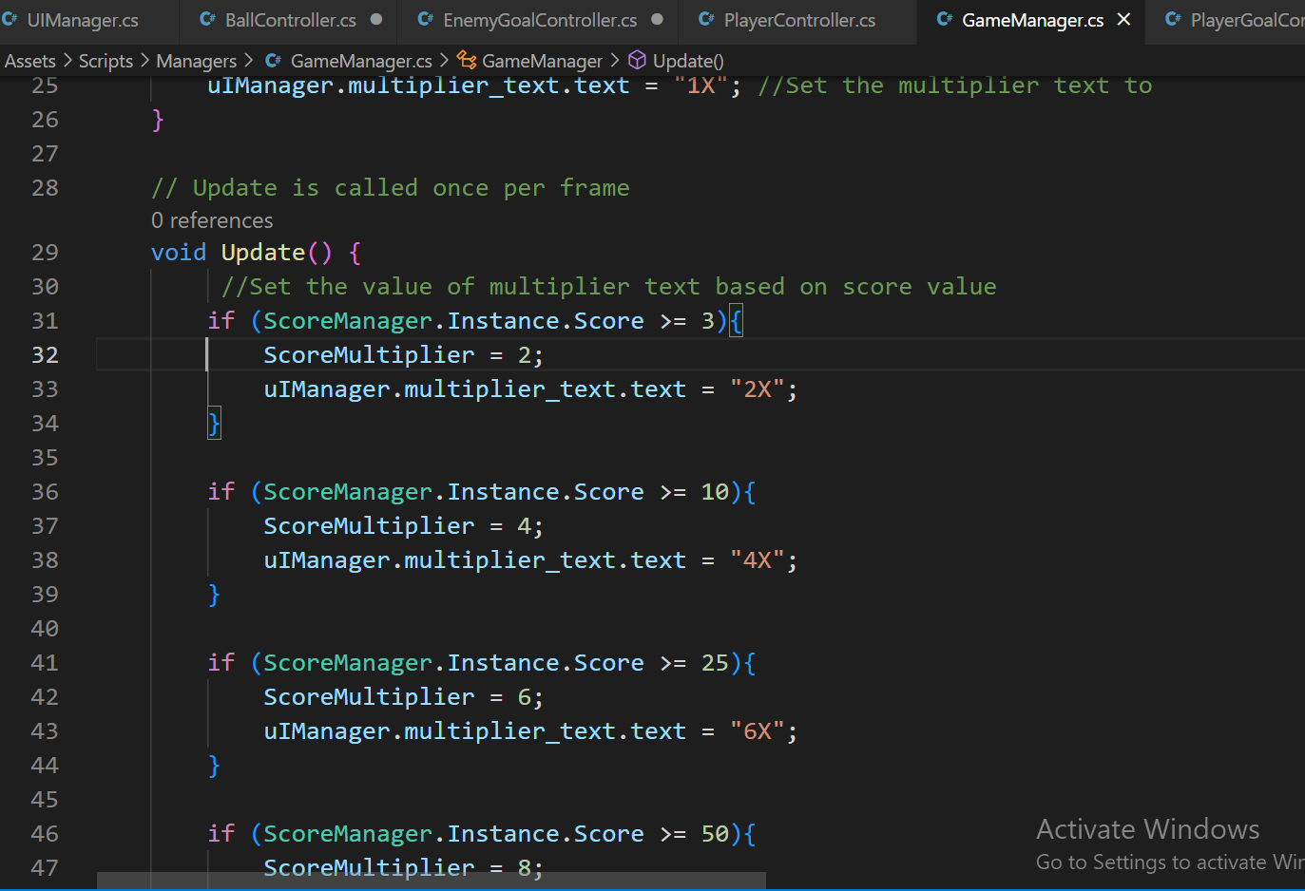

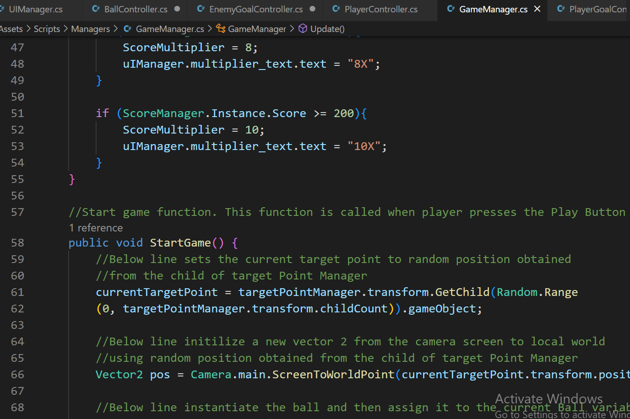

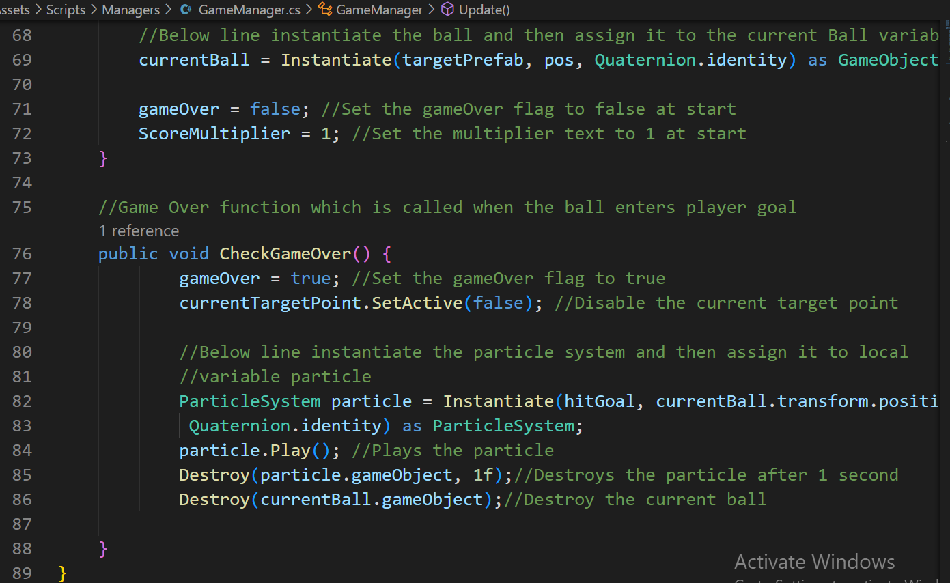

**Score Manager**

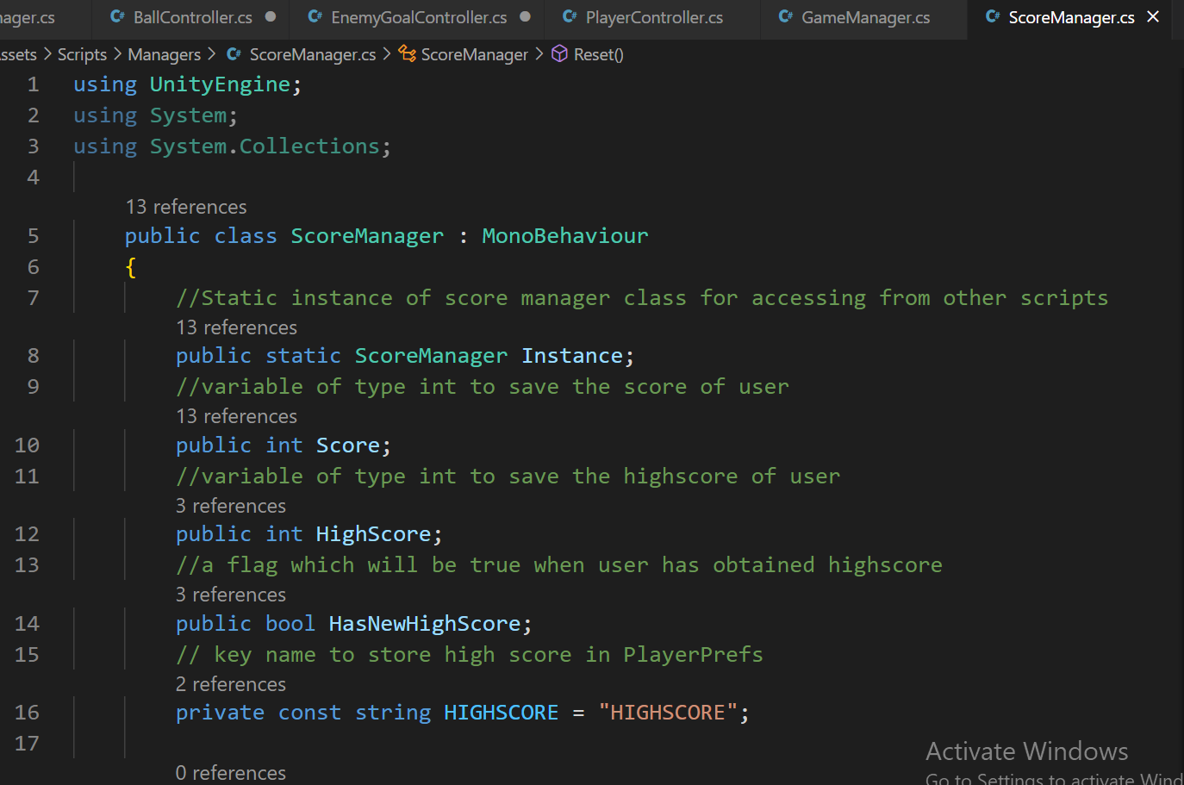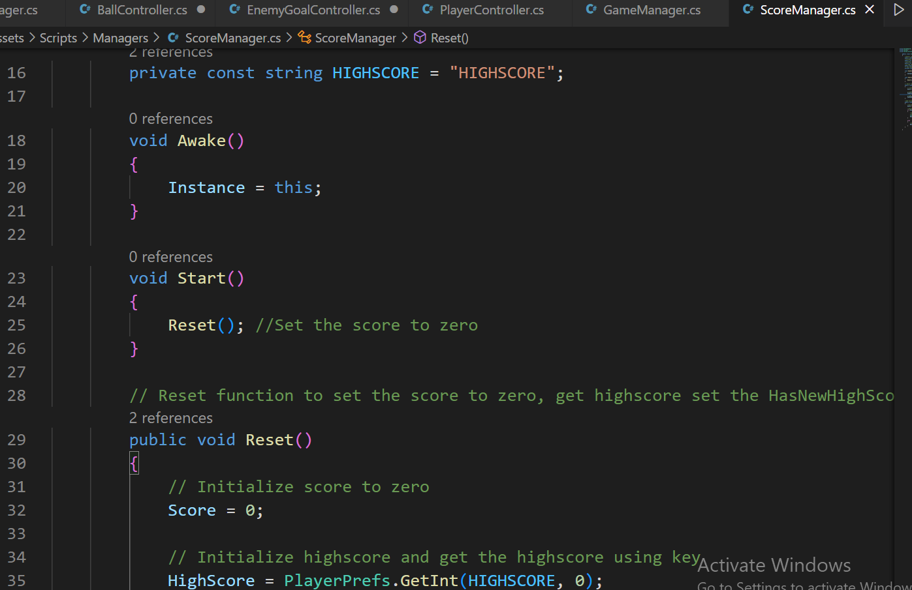

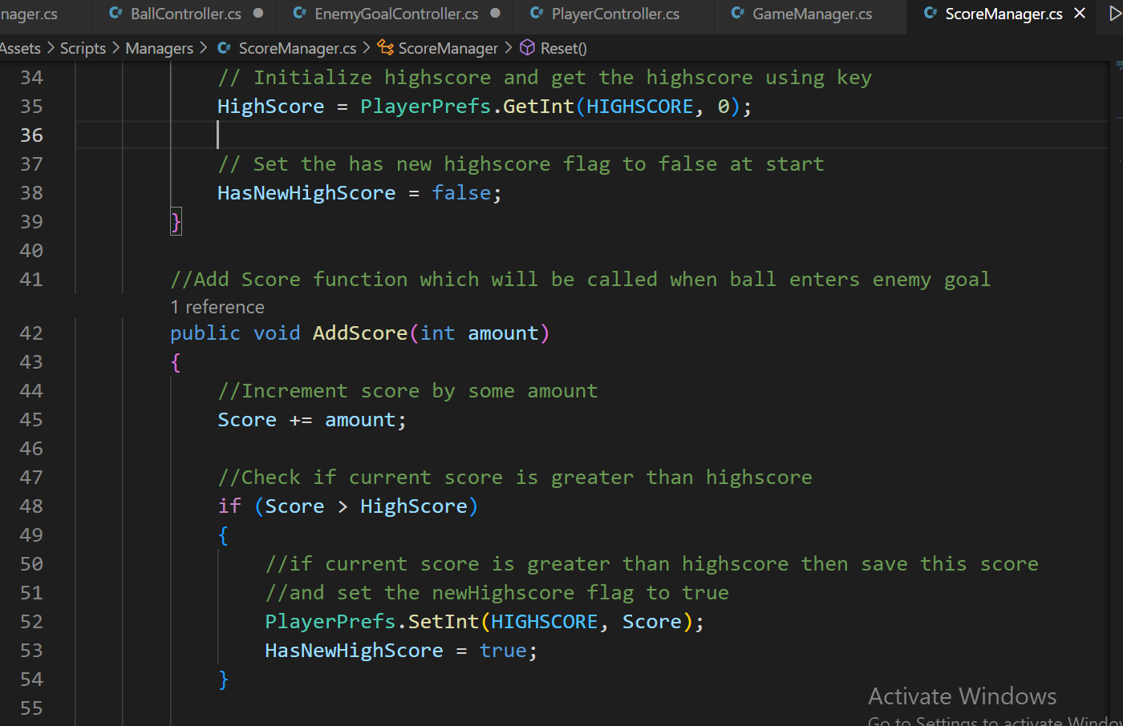

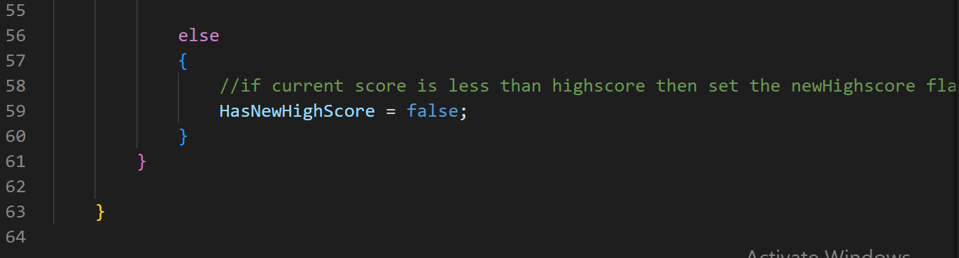

**UI Manager**

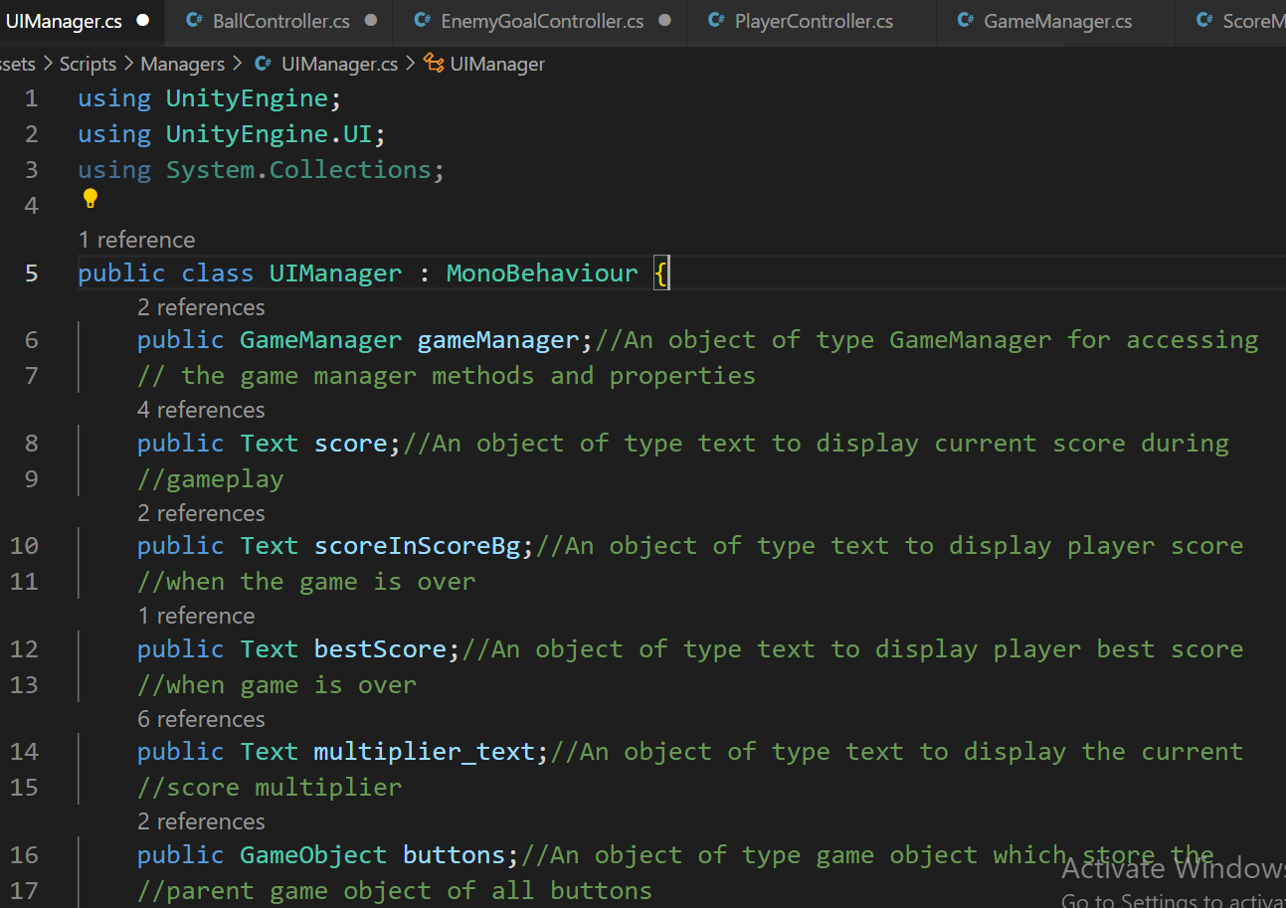

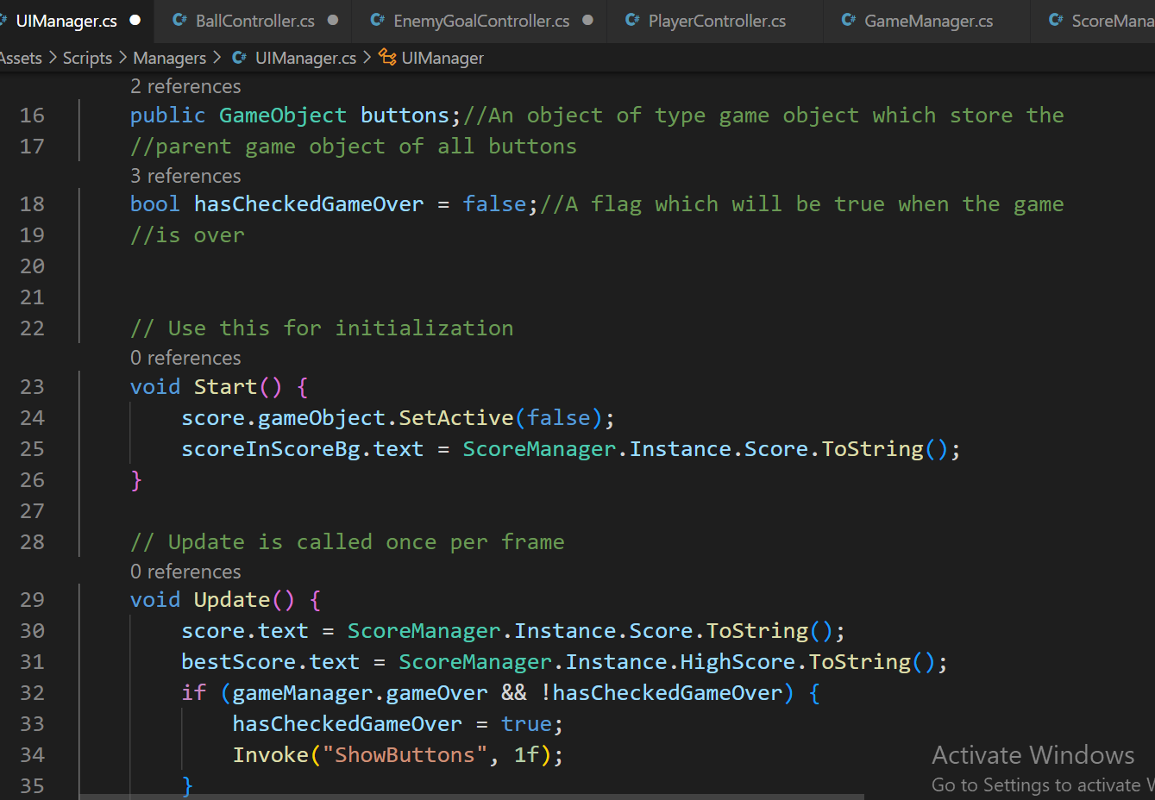

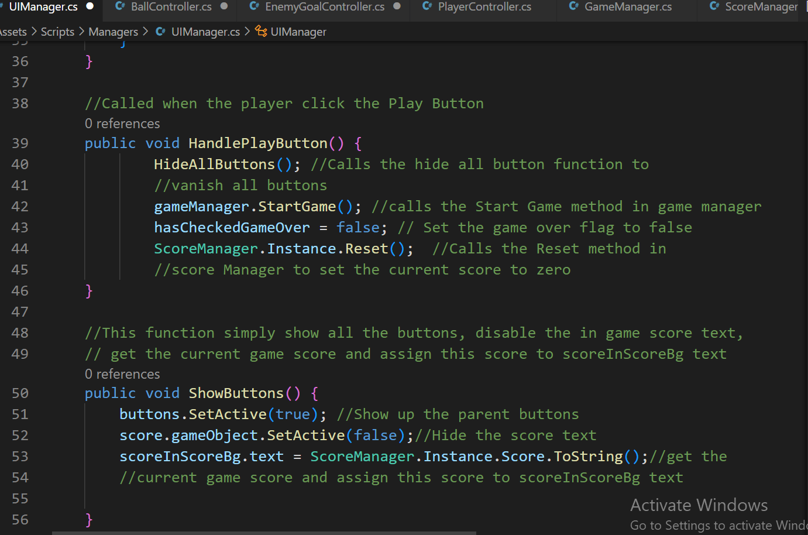

**GAME SCREENSHOTS:**

